需求补充说明 – 161222

1. 结构预定规则。

在program实体中，当生成一个新的program，在GroupedLineSections中，自动加入一个根Group，在每个Job Type的GroupSection下面都有四个GroupSection，分别是Services, Handling & Delivery, Materials and Miscellaneous Items.

在导入中，根据Bundle Name去找到相应的GroupSection, 然后把之后的列表中数据加到它的下面。Bundle Header下面的数据（例如：A30 to H35）不用导入，略过。

1. 导入Program ID（C19）

在导入模板中，新增加了Program ID项，原来代码中有系统根据数据库ID自动生成Program ID的功能，需要去掉，直接读取导入的数据赋值就可以了。

1. 在Job Type Section 中，新增了一个Depth Base Charge. 我回头找一个数据项存它。
2. 新增Template ID（C20）, 这是template的版本，在导入代码实现的，要能根据版本来确定导入规则集。因为在之后我们可能会对template进行多次优化。
3. Well Location （Surface）（E3）导入到 Surface Well Location，类型为General
4. Well Location （UWI）(E4)导入到 Downhole Well Location，类型为General
5. TMA (E14)和TMA %(E15)略过
6. A21 to F23, 略过，缺省值都为1
7. F6 to F8, F14, F15略过
8. A25 – C25, 略过
9. C26略过
10. Total 整行不用导入
11. 在Items列表中会有类似下面的行，特点的是，Item Code不是数字，略过

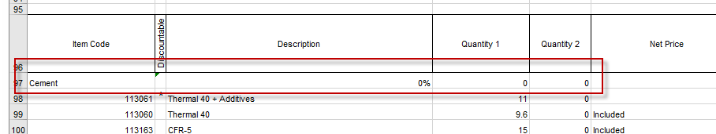

2017/01/03 – Change update

For the Job Type Section, we use

PriceItemNumber to host JobTypeId

Travel Base Charge and Depth Base Charge are saved in PricingInformationSection.

Previous use of PriceItemId for Depth Base Charge is removed.

Please see full test data for your reference.

2017/01/04 – Change Update

1. “Net Price” and “Adj Net Price” control need to be added to GroupedLineItemControl. “Net Price” read-only——3h
2. In LineItemEditControl, add and verify following logic,
   1. When adding new, populate discount from default value in Charge Method.(Existing Logic, no change)
   2. “Adj Unit Price” change to read-only (New change)
   3. On “Adj Quantity/Unit” change, re-calcuate all amount with “Adj Quantity/Unit”, “Adj Unit Price”, “Adj Discount” and “Adj Net Price” (Existing logic, no change)
   4. On “Adj Discount” change, re-calculate “Adj Net Price” and then re-calcuate all amount with “Adj Quantity/Unit”, “Adj Unit Price”, “Adj Discount” and “Adj Net Price” (Existing logic, no change)
   5. On “Adj Net Price” change, re-calculate “Adj Discount” and then re-calcuate all amount with “Adj Quantity/Unit”, “Adj Unit Price”, “Adj Discount” and “Adj Net Price” (New Change)
3. Grouping and bundle calculation has not finish yet. Refer to “Pricing Information Element Definition” to understand how to do the calculation. Review current calculation implementation to create list of test cases. Prepare to start working on calculation.
4. Understand Calculation, describe how to update historical data for Net Price.
5. Input program, the quantity of Group Item is always 1. Now they are set as 0---

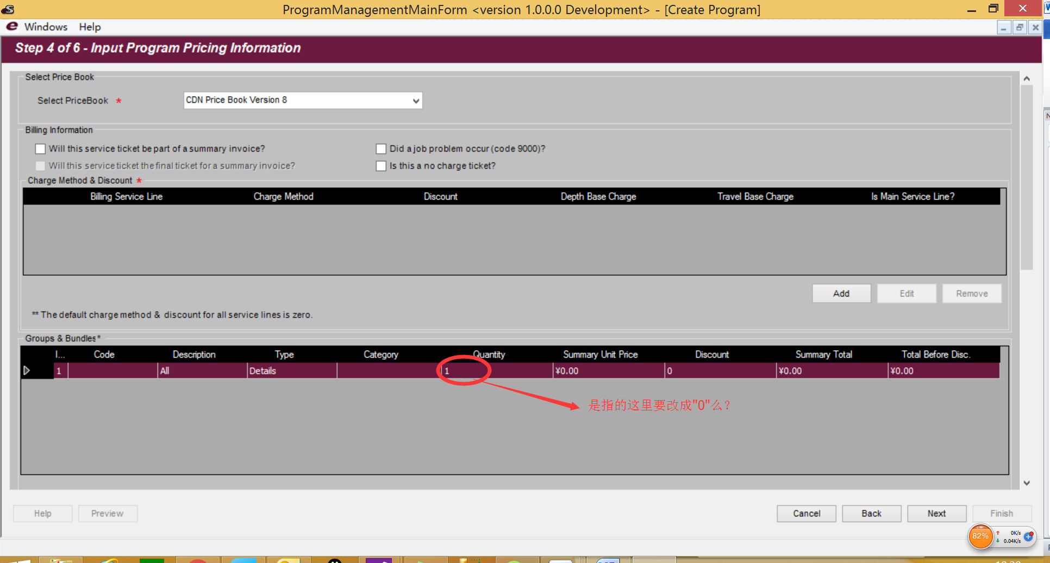

1. Create call sheet from program, Call Sheet Type need to be default as Pumping in entity.---3.
2. Create call sheet from program, root group is missing. No matter what, root group is always there.---2
3. Create call sheet from program, Job Designer and Client Solutions Representative should be copied over.---

2017/01/05 – Change Update

1. Bug: When creating callsheet without program, the start page should be Setp 4. Currently it starts from Step 3 which shows empty job type.